Directions: The goal of the following problems is to help challenge and deepen your understanding of the current topic. Don’t assume that you will know how to answer each and every question. You will work with at least two other students in the class to try and find solutions and write arguments for each of the following questions. Be sure that you question your classmates’ reasoning. If you don’t understand how they are getting something you should ASK THEM TO EXPLAIN! Being able to defend your reasoning is important and so you are actually helping them by asking them to explain.

Challenge Questions
- Determine the value of the definite integral .
We note that is continuous on and so we can proceed with using the FTCP2.

- Why can’t the definite integral be computed based on our current knowledge?
We note that is NOT continuous on , specifically at , and so we CANNOT proceed with using the FTCP2.

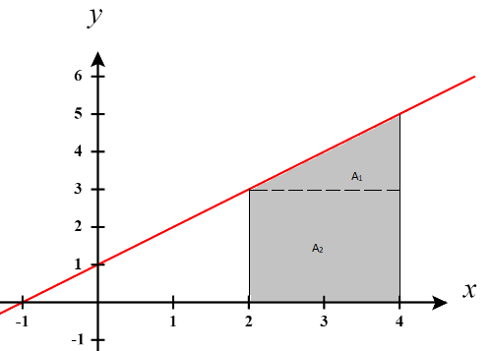
- Consider the definite integral .
- Compute the value of the integral using geometry.

We see that this region can be thought of as a triangle atop a rectangle. We call the area of the triangle and the area of the rectangle . We see that and .
Therefore, we have that .

- Compute the value of the integral using the FTCP2.

We note that is continuous on and so we can proceed with using the FTCP2.

- Compute the value of integral using the limit definition of the definite integral.

Width of Rectangles | Right Endpoints | Height of Rectangles
Therefore, we can say that . We then calculate:
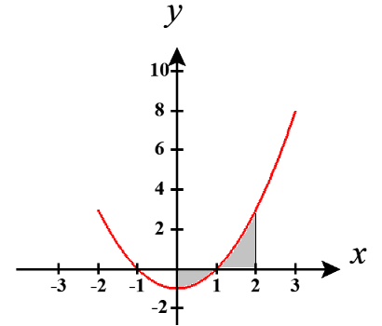
- Consider the definite integral .
- Compute the value of the integral using the FTCP2.

We note that is continuous on and so we can proceed with using the FTCP2.

- Compute the value of integral using the limit definition of the definite integral.

Width of Rectangles | Right Endpoints | Height of Rectangles
Therefore, we can say that . We then calculate:
- Evaluate each of the following integrals.

We note that is continuous on and so we can proceed with using the FTCP2.

We note that is continuous on and so we can proceed with using the FTCP2.

We note that is NOT continuous on , specifically at since and so we cannot proceed with using the FTCP2 and we aren’t able to finish answering this question.

We note that is continuous on and so we can proceed with using the FTCP2.

- The function is defined on by .
- Show that .

We calculate that and then
The function is clearly continuous as long as . Based on the domain of we can see that the bounds of the integral will always exist between 0 and 1 and so is continuous on . So the FTCP1 can be applied.

- Compute the value of H at .

We compute

- Use the results of parts (a) and (b) to determine .

Based on part (a) we know that since then .
From part (b) we know that and so this implies that
This means that . This implies that .

- Compute the following limit . Hint: Consider how rewriting this limit using properties of integrals can be helpful.

Note that

We note that . Therefore, we have that

